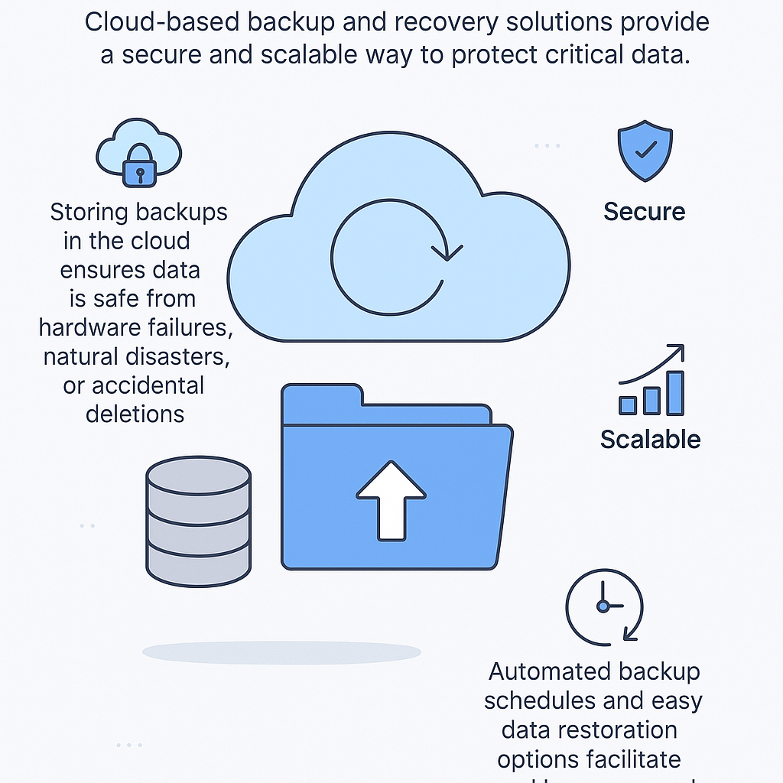3

.0

.

The design visually explains the benefits of cloud-based backup and recovery solutions for protecting critical data. It uses simple icons and text to convey key advantages.

Here's a breakdown of the design elements:

* Central Cloud Icon with Circular Arrows: This prominent icon represents cloud computing and the continuous nature of backup and recovery processes. The circular arrows suggest data flowing into and potentially being restored from the cloud.
* Locked Cloud Icon with Text: Positioned to the left, this icon illustrates the security aspect. The padlock symbolizes that data stored in the cloud is protected. The accompanying text explains that storing backups in the cloud safeguards data against hardware failures, natural disasters, or accidental deletions.1
* Folder Icon with Upward Arrow: Located below the central cloud, this represents the process of backing up data and sending it to the cloud. The upward arrow clearly indicates data being uploaded.
* Stack of Cylinders Icon: Situated to the left of the folder, this likely symbolizes on-premises data storage before backup. It contrasts with the cloud storage represented by the locked cloud icon.
* Shield Icon with Checkmark and "Secure" Label: Placed on the right side, this reinforces the security benefit of cloud backups. The shield is a universal symbol for protection, and the checkmark indicates assurance.
* Bar Graph Icon with Upward Trend and "Scalable" Label: Also on the right, this visually represents the scalability of cloud solutions. The increasing bars show that storage capacity can grow as needed.
* Clock Icon with Arrow and Text: Positioned at the bottom right, this highlights the automation and ease of use. The clock and arrow suggest scheduled processes, and the text explains that automated backup schedules and easy data restoration options facilitate seamless recovery.
* Headline Text: At the top, the text "Cloud-based backup and recovery solutions provide a secure and scalable way to protect critical data" summarizes the main message.
* Clean and Simple Style: The design uses a clean, flat illustration style with a limited color palette (primarily light blue and grey). This makes the information easy to understand and visually appealing.

In essence, the design effectively communicates that cloud-based backup offers a secure, scalable, and automated way to protect valuable data from various potential threats.